**Outline**

1. Definition of stakeholder
2. Typical stakeholders
3. Stakeholder management
4. Stakeholder Analysis
5. The stakeholder register

**Stakeholder definition**

People, groups or organizations that could impact or be impacted by the project

**Stakeholder management**

Identify stakeholders, analyze stakeholder expectations and their impact on the project, and develop appropriate management strategies for effectively involving stakeholders in project decisions and execution.

**The stakeholder register**

1. Used throughout the project
2. A table used to manage interactions with the stakeholders
3. Lists all stakeholders and stakeholder groups
4. Information added and updated throughout the phases of the project:
   1. Interests, involvement, interdependencies, influence on project success
   2. All interactions with each stakeholder or group, whether planned or not, whether initiated by the project or by the stakeholder
   3. Who on the project team is responsible
5. Closely related to the project communication plan

**Project Initiation: Identify Stakeholders**

1. Top Management
2. Your Manager
3. Peers
4. Resource Managers
5. Internal Customers
6. External Customers
7. Government
8. Contractors, Subcontractors, Suppliers
9. Others (the public, landowners, interest groups, and business competitors)

**Stakeholder Analysis**

1. Who are they?
2. What are their interests?
3. Will their interest level vary throughout the project?
4. Can coalitions be built?
5. The power/interest grid

**Project sponsor**

1. The person or group responsible for enabling success.
2. May be inside but is usually outside the project.
3. Signs off that the project is complete—the one the PM has to satisfy.
4. The person responsible for escalating issues that are beyond the control of the PM.
5. Significant role in developing the initial charter and project plan.

**Politics of Projects**

1. The environment
2. The goals of each stakeholder or group
   1. Goals that are openly stated or clear
   2. Hidden agendas?
3. Power

**Cultural influences**

Groups and individuals may differ with regard to:

1. Communications
2. Negotiations
3. Decision-making

**Relationship building**

1. Analyze stakeholders
2. Assess influence
3. Understand expectations
4. Define success
5. Keep stakeholders involved
6. Keep stakeholders informed

**Build respect**

1. Be honest
2. Take ownership
3. Be predictable and reliable
4. Stand by decisions
5. Take accountability for mistakes

Supportive stakeholders are essential to project success!

**Stakeholder management tools**

1. Power/interest matrix
2. Cooperation-Threat matrix
3. Stakeholder analysis template
4. Stakeholder Register
5. Communication Plan 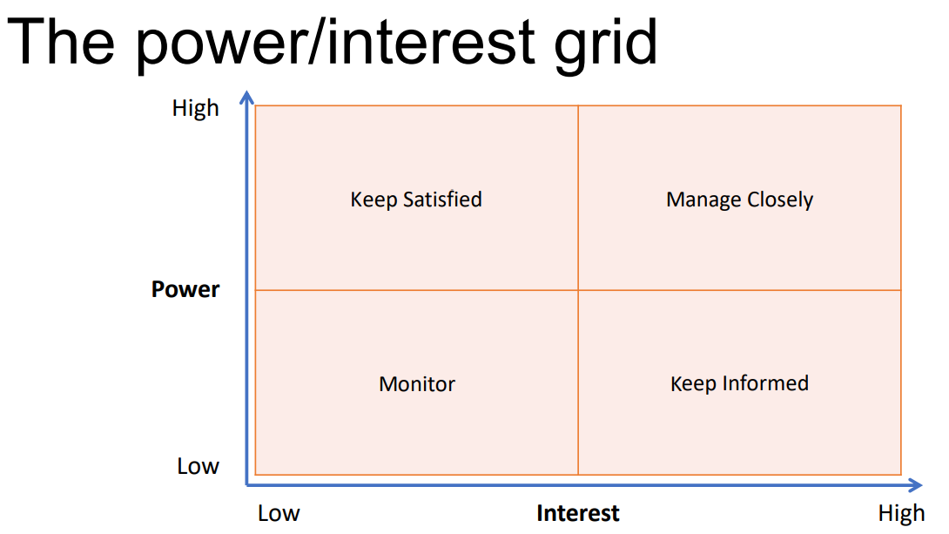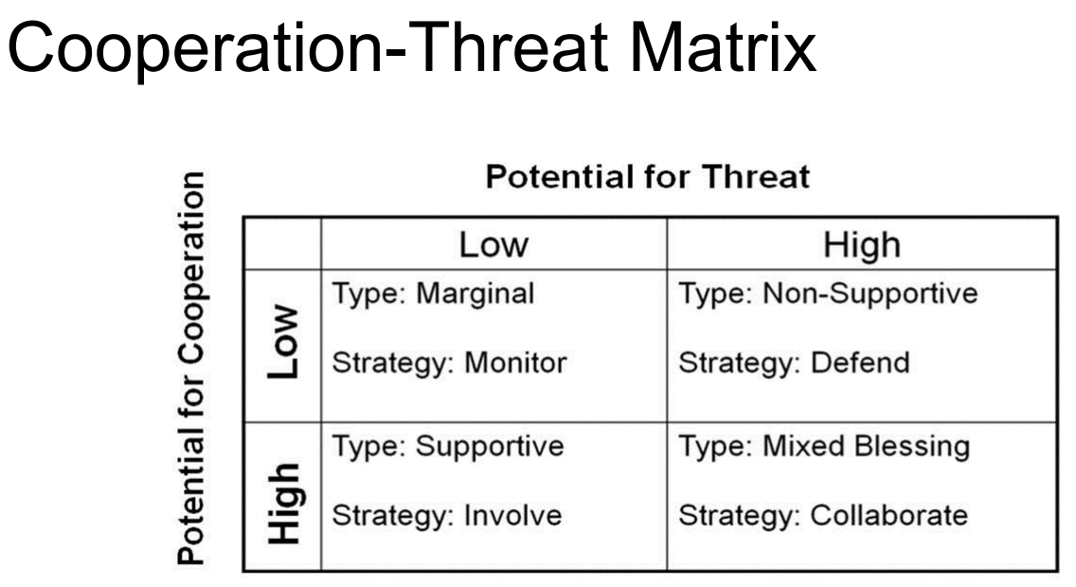

**Engagement levels**

1. May classify in more detail than in the Initiation phase:
   1. Unaware
   2. Resistant
   3. Neutral
   4. Supportive
   5. Leading
2. For each stakeholder or group. Consider potential movement from one level to another throughout the project.

**Stakeholder management plan**

A component of the Project Management Plan

1. Desired and current engagement levels with stakeholders
2. Scope and impact of the project on stakeholders
3. Interrelationships between stakeholders
4. Stakeholder communication requirements and plan
5. Time frame, frequency, format and content of planned communications to stakeholders
6. Method for updating the stakeholder management plan\

**Manage Stakeholder Engagement**

1. Communicating and working with stakeholders to meet their needs and expectations
2. To increase support and reduce resistance from stakeholders
3. Increase the probability of project success

**Stakeholder Management Summary**

1. Stakeholders are people, groups or organizations that could impact or be impacted by the project
2. Managing stakeholders is a key success factor for projects
3. Analyze stakeholder interests and level of influence
4. Build coalitions
5. Communicate with Stakeholders